Terraform Installation in Linux

Link: https://www.terraform.io/downloads

Commands:
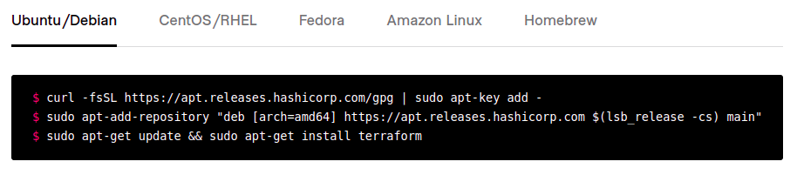
Command 1:

Command 2 ->
Error encountered:
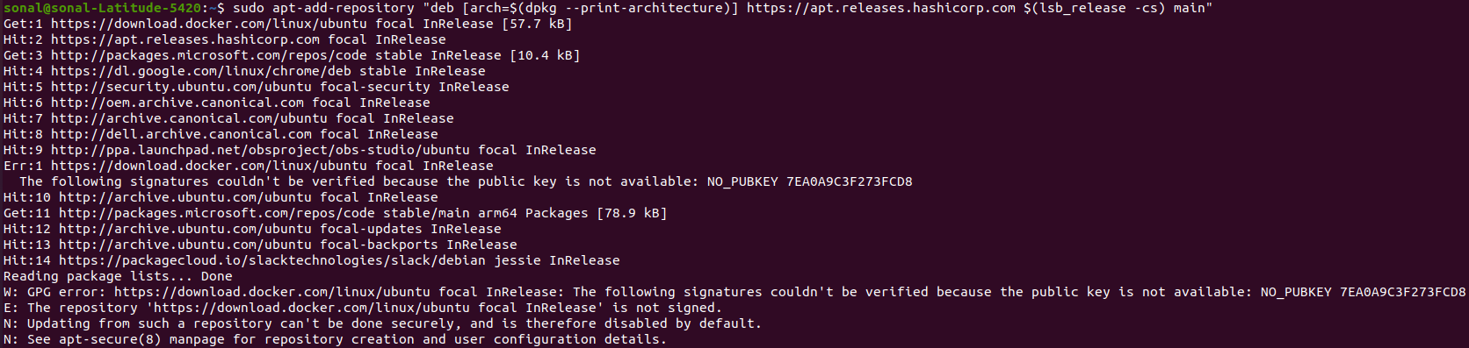
Solution: https://linuxconfig.org/ubuntu-20-04-gpg-error-the-following-signatures-couldn-t-be-verified

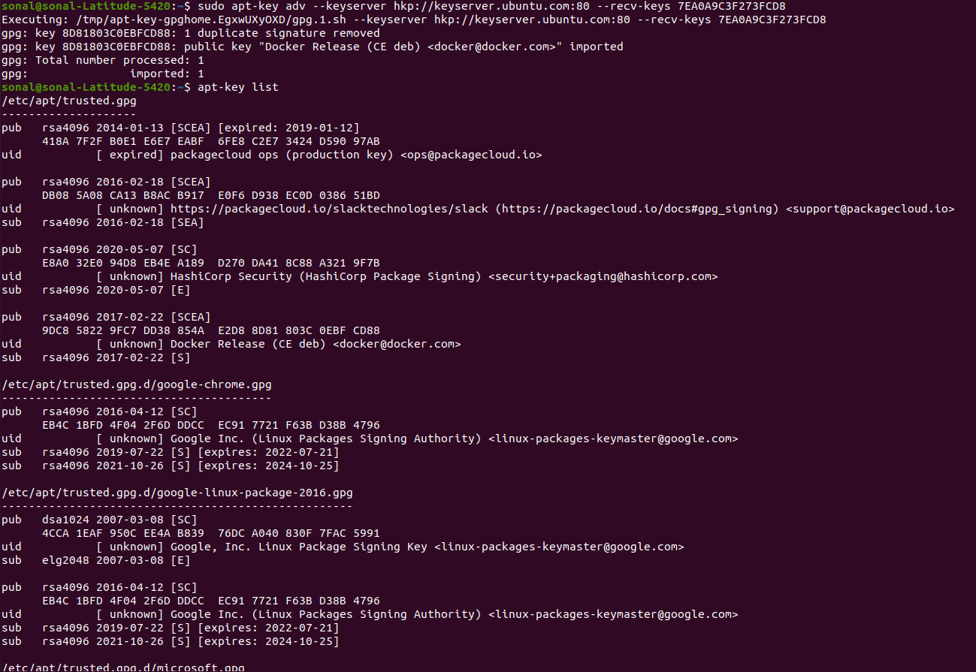

Then again ran the 2nd command
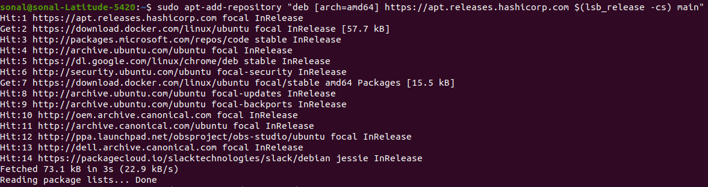

Next command:
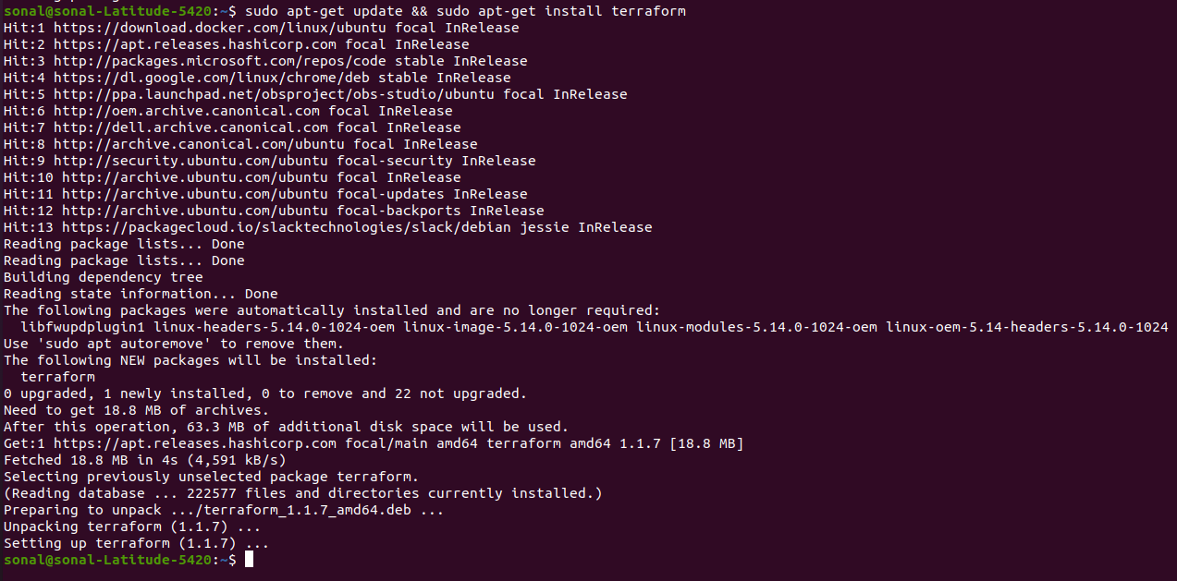
verify whether terraform is installed
